Demographic CLTV Analysis (Age Group & Gender)
Calculates key e-commerce metrics—such as total revenue, average order value, purchase frequency, and historical customer lifetime value (CLTV)—grouped by customer gender and age group for successful transactions.

QUERY -;
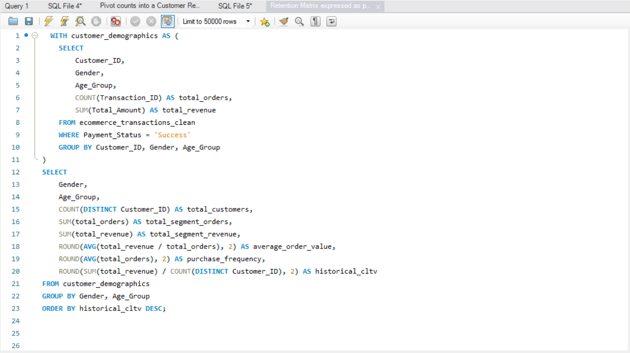
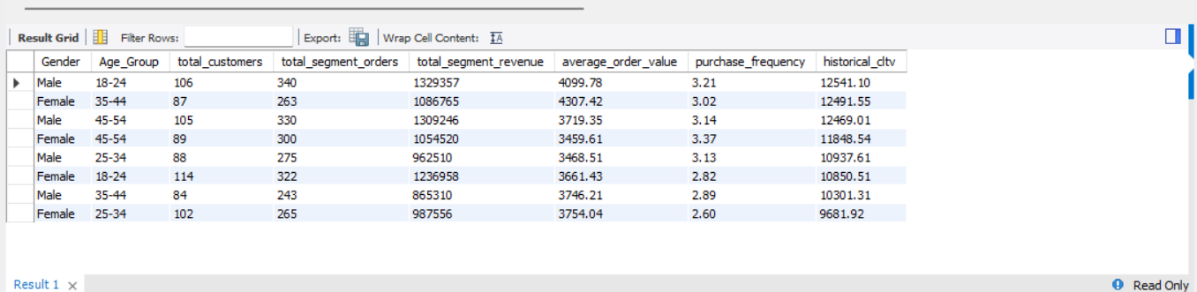

OUTPUT-;

